Report: Optimising NYC Taxi Operations
This report summarises the data preparation, cleaning, exploratory analysis, visualisations, key insights, and recommendations from the NYC yellow taxi operations analysis conducted in the accompanying notebook.

1. Data Preparation

1.1 Loading the dataset

1.1.1 Sample the data and combine the files
The dataset consists of New York City yellow taxi trip records for 2023. The monthly parquet files were read and sampled by pickup date and pickup hour so that every hour of every day was represented in the final sample. This avoids taking a random sample that over-represents only busy periods.
One monthly file had 3,041,714 rows before sampling. After combining the 12 monthly files and applying a 0.7% sampling rate, the working dataset contained 276,397 rows and 22 columns.

2. Data Cleaning

2.1 Fixing Columns

2.1.1 Fix the index
The column store_and_fwd_flag was dropped because it was not needed for the main operational analysis. After filtering and dropping rows, the dataframe index was reset using reset_index(drop=True), which replaced the old row labels with a clean sequential index starting from 0.

2.1.2 Combine the two airport_fee columns
Two airport-fee related columns were combined into one column named airport_fee_combined. Missing values in the combined airport fee column were replaced with 0.

2.2 Handling Missing Values

2.2.1 Find the proportion of missing values in each column
The main missing values were found in passenger_count, RatecodeID, congestion_surcharge, and airport fee fields. The missing proportion for passenger_count, RatecodeID and congestion_surcharge was approximately 3.35%.

2.2.2 Handling missing values in passenger_count
The passenger_count column had 9,566 missing values and 4,356 zero values. Since passenger count is a discrete operational field, missing and zero values were treated as invalid or unavailable and imputed with the most common passenger count. The dominant category was one passenger, which is consistent with taxi trip behaviour.

2.2.3 Handle missing values in RatecodeID
RatecodeID had 9,566 missing values. These were filled with the mode value of 1.0, representing the standard rate category. This was reasonable because most trips follow the standard rate.

2.2.4 Impute NaN in congestion_surcharge
The congestion_surcharge column had 9,566 missing values. These were filled with 0, assuming no recorded congestion surcharge for those trips. After these treatments, all remaining missing values were removed or imputed.

2.3 Handling Outliers and Standardising Values

2.3.1 Check outliers in payment type, trip distance and tip amount columns
Outliers were checked using summary statistics, value counts, and boxplots. Passenger counts greater than 6 were removed because only a few records had values 7, 8, or 9. Negative values in improvement_surcharge, total_amount, and congestion_surcharge were set to 0. Invalid payment_type = 0 records were removed, leaving payment types 1, 2, 3, and 4 only.
Records with almost zero distance but very high fares, zero fare and zero distance for different pickup/dropoff zones, and unrealistic trip distances above 250 miles were treated as outliers. Some values were dropped, while likely registration errors were replaced using median-based or typical values where appropriate.
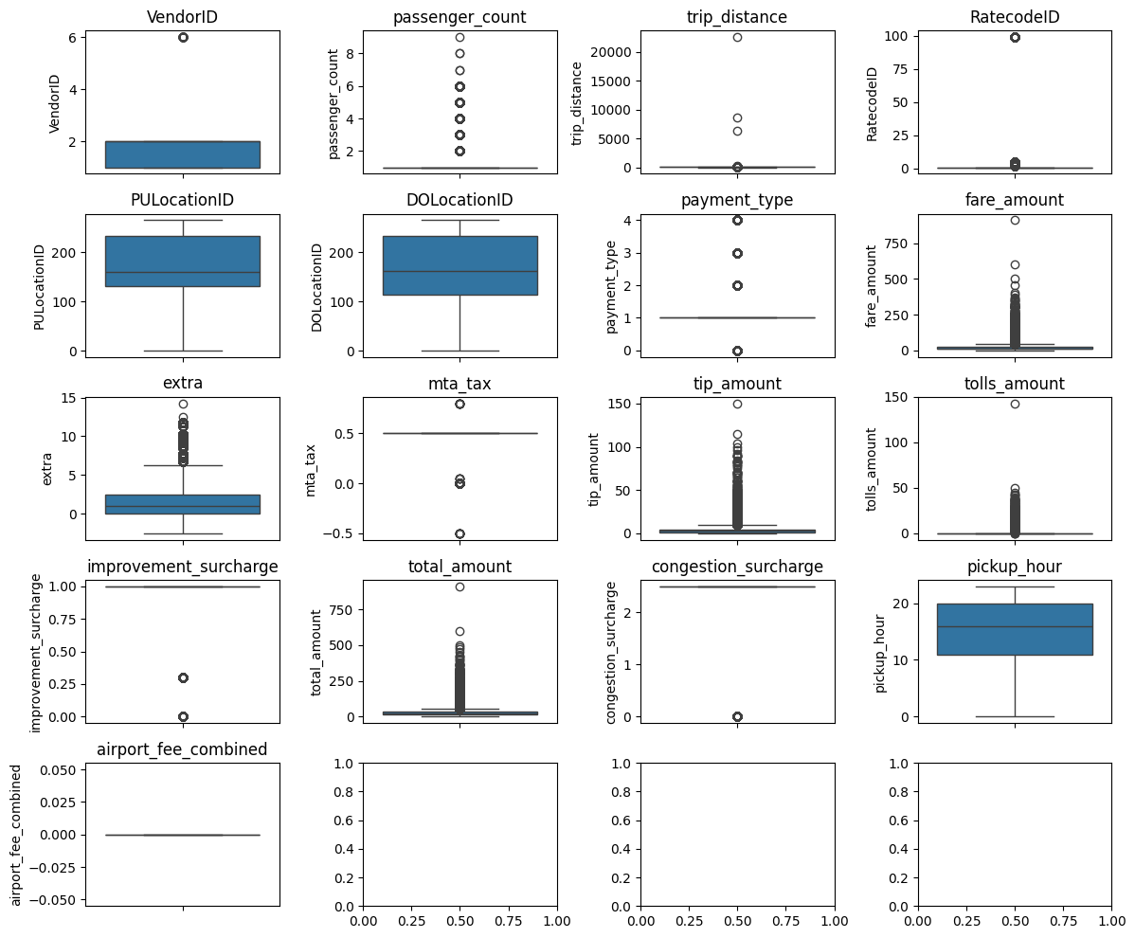
Figure 1: Boxplots used to inspect potential outliers in numeric columns.

3. Exploratory Data Analysis

3.1 General EDA: Finding Patterns and Trends

3.1.1 Classify variables into categorical and numerical
Numerical variables included passenger_count, trip_distance, fare_amount, extra, mta_tax, tip_amount, tolls_amount, improvement_surcharge, total_amount, congestion_surcharge, airport_fee_combined, pickup_hour, trip_duration, and derived fare metrics. Categorical variables included VendorID, RatecodeID, PULocationID, DOLocationID, payment_type, pickup_day, pickup_month, quarter, day_type, and distance_tier.

3.1.2 Analyse the distribution of taxi pickups by hours, days of the week, and months
Pickup demand varied strongly across time. The highest hourly demand occurred late in the day, with hour 23 showing the highest sampled trip count. Demand was lower during early-morning hours, especially around 3 AM to 5 AM. Monthly trends were uneven, with higher revenue and activity in spring and October compared with late summer and September.
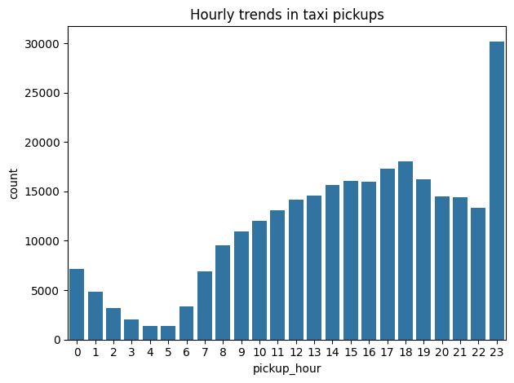
Figure 2: Distribution of taxi pickups by hour.
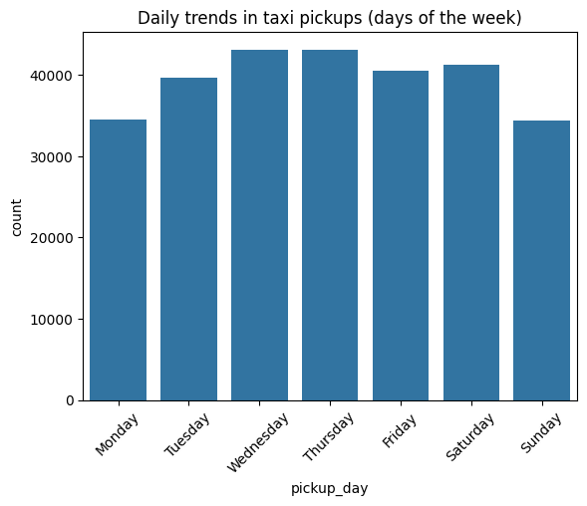
Figure 3: Distribution of taxi pickups by day of week.
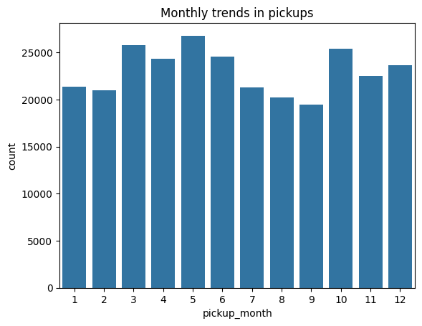
Figure 4: Distribution of taxi pickups by month.

3.1.3 Filter out the zero/negative values in fares, distance and tips
A clean dataframe was created by filtering invalid or zero values from fare amount, total amount, and trip distance where required. After cleaning, the dataset used for EDA had 275,169 rows. The median trip distance was about 1.81 miles and the median fare amount was 13.50 dollars.
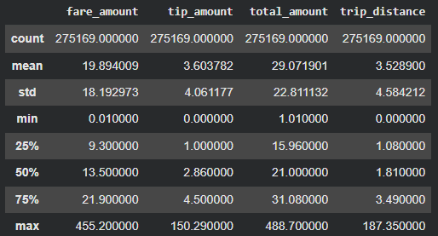

3.1.4 Analyse the monthly revenue trends
Monthly revenue was highest in May at approximately $786,642, followed by October at about $762,094 and March at about $729,826. February and September had comparatively lower revenue at about $572,960 and $585,193 respectively.
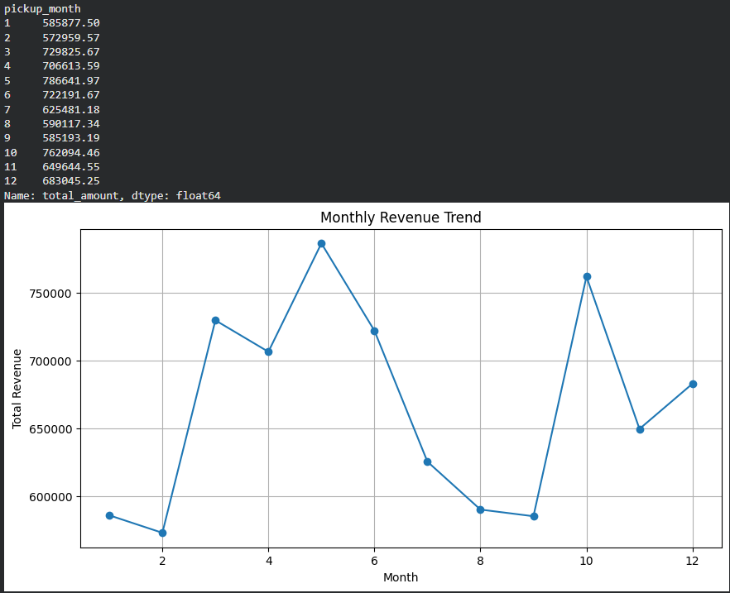

3.1.5 Find the proportion of each quarter’s revenue in the yearly revenue
Quarter 2 contributed the highest revenue share, followed by Quarter 4. Quarter 3 had the lowest share. This indicates that the operator should plan for higher demand in spring/early summer and in the year-end period.
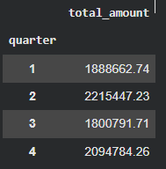
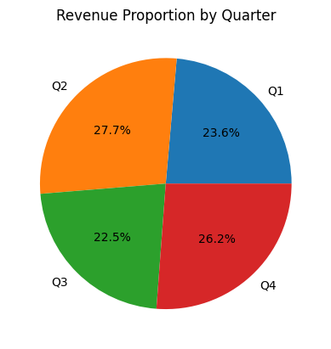
Figure 5: Quarterly revenue contribution.

3.1.6 Analyse and visualise the relationship between distance and fare amount
Fare amount generally increased as trip distance increased, which confirms the expected distance-based pricing relationship. Short trips were more frequent, while long trips showed higher fares but also greater variability.
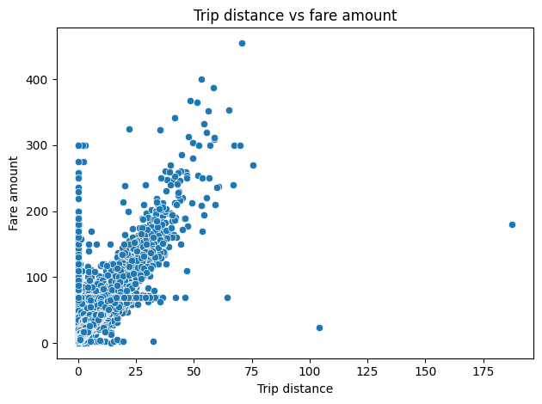
Figure 6: Relationship between trip distance and fare amount.

3.1.7 Analyse the relationship between fare/tips and trips/passengers
Fare amount also increased with trip duration. Passenger count did not strongly increase fare amount because fare is primarily based on distance, time, and surcharges rather than the number of passengers. Tip amount tended to increase with distance, although there was high variation across trips.
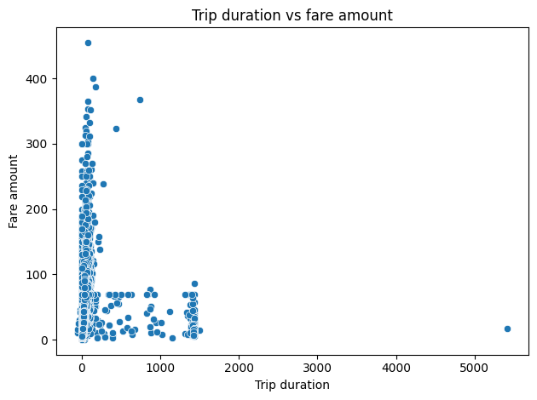
Figure 7: Trip duration versus fare amount.
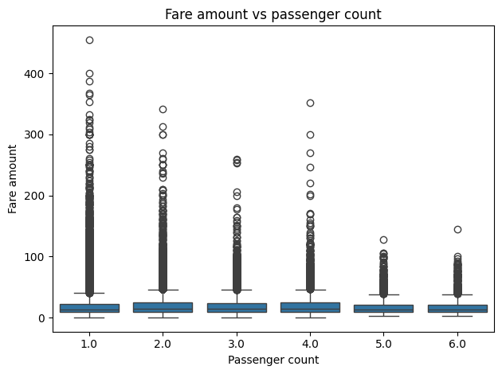
Figure 8: Passenger count versus fare amount.
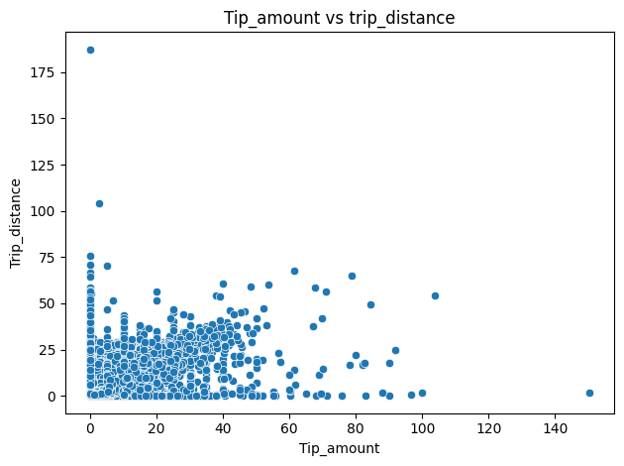
Figure 9: Tip amount versus trip distance.

3.1.8 Analyse the distribution of different payment types
Payment type 1 was the most common payment method, followed by payment type 2. Payment types 3 and 4 were much less frequent. This suggests most customers use the two main defined payment modes, while dispute/no-charge or other categories are rare.
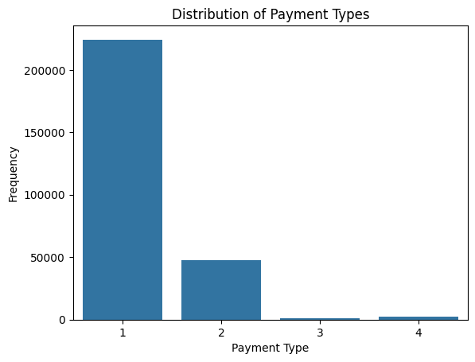
Figure 10: Distribution of payment types.

3.1.9 Load the taxi zones shapefile and display it
The NYC taxi zone shapefile was loaded using GeoPandas. It contained zone geometry, LocationID, borough, and zone names. This allowed spatial analysis of pickup/dropoff patterns.
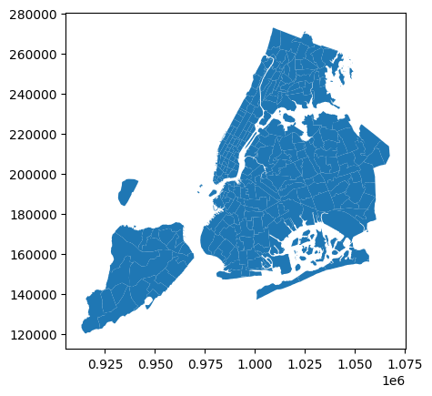
Figure 11: NYC taxi zone shapefile.

3.1.10 Merge the zone data with trips data
Trip records were merged with the zones dataframe using PULocationID and LocationID so that each trip could be connected to a pickup zone and borough.

3.1.11 Find the number of trips for each zone/location ID
The number of pickups was grouped by PULocationID.
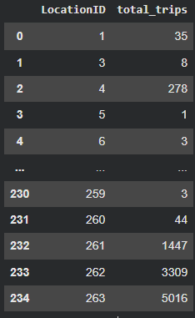

3.1.12 Add the number of trips for each zone to the zones dataframe
The grouped trip counts were added back to the GeoDataFrame so that each spatial zone had an associated trip count.

3.1.13 Plot a map of the zones showing number of trips
The map showed that trip demand is spatially concentrated in major airport, Manhattan, and central business/activity zones. This is useful for fleet positioning and demand forecasting.
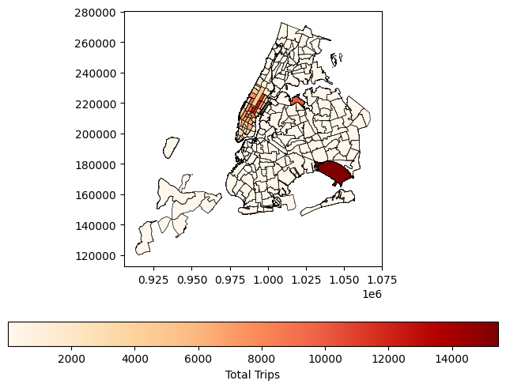
Figure 12: Taxi zones coloured by total trips.

3.1.14 Conclude with results
The general EDA shows strong time, location, and distance effects. Demand is highest in late evening and in central/high-traffic zones. Revenue is driven by both high trip volumes and longer-distance trips. Fare and distance have a clear positive relationship, while passenger count has weaker influence on fare.

3.2 Detailed EDA: Insights and Strategies

3.2.1 Identify slow routes by comparing average speeds on different routes
Routes were defined using pickup and dropoff location IDs, and the average speed for each route was calculated across different hours of the day using average trip distance and average trip duration. The analysis revealed that traffic congestion and taxi movement efficiency vary significantly by both route and time of day. Several routes showed noticeably lower average speeds during peak traffic hours, indicating potential operational bottlenecks and high-congestion corridors.
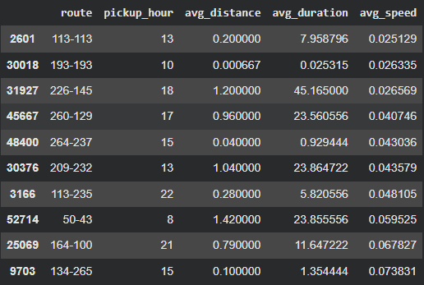
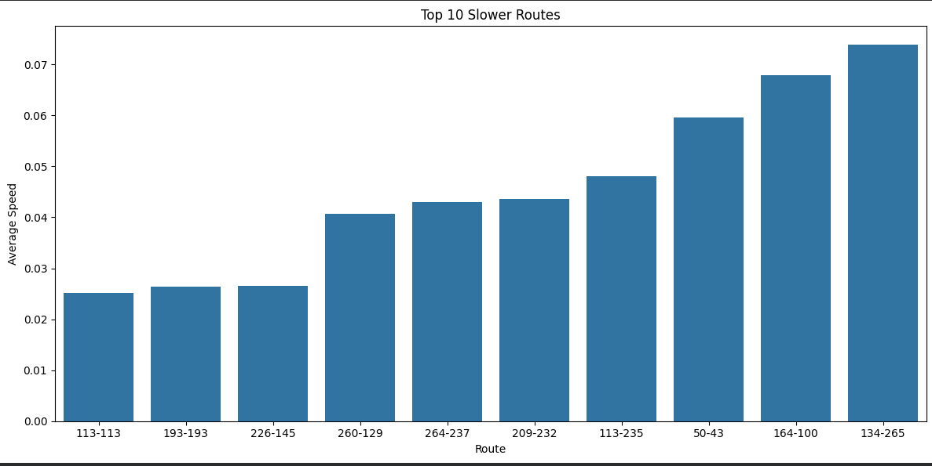

3.2.2 Calculate the hourly number of trips and identify the busy hours
The busiest sampled hour was 23:00 with 30,099 trips. Other busy hours included 18:00, 17:00, 19:00, and 15:00. Early-morning hours had much lower activity.
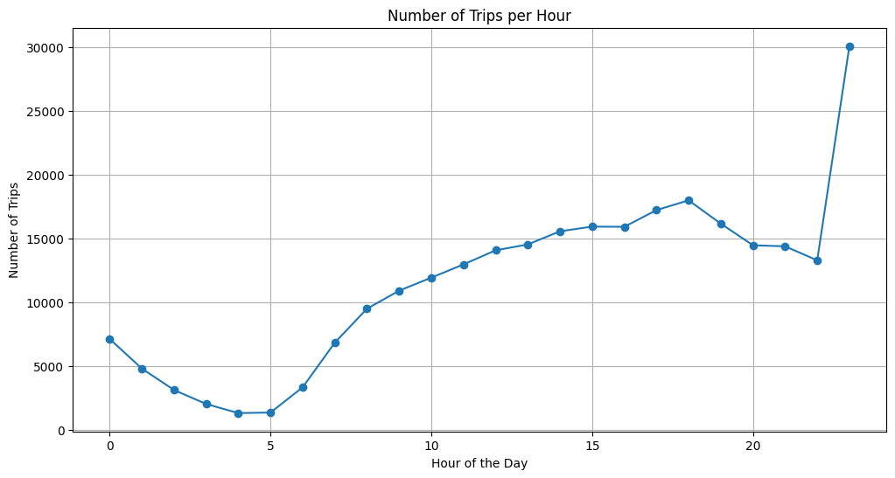
Figure 13: Hourly number of trips.

3.2.3 Scale up the number of trips from above to find the actual number of trips
Because the sample rate was 0.7%, sampled hourly counts were scaled up by dividing by 0.007. The estimated actual number of trips at 23:00 was about 4.30 million. The next highest scaled counts were around 2.57 million at 18:00 and 2.46 million at 17:00.
Pickup hour | Sampled trips | Estimated actual trips
23 | 30099 | 4,299,857
18 | 18007 | 2,572,429
17 | 17238 | 2,462,571
19 | 16179 | 2,311,286
15 | 15945 | 2,277,857

3.2.4 Compare hourly traffic on weekdays and weekends
Weekday and weekend traffic showed different hourly patterns. Weekday demand was stronger during commuting and evening periods, while weekend demand was more concentrated in late evening and night-time activity periods.
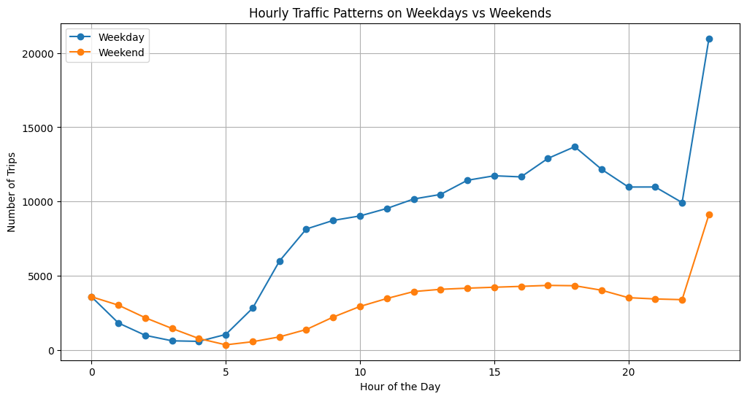
Figure 14: Hourly traffic comparison for weekdays and weekends.

3.2.5 Identify the top 10 zones with high hourly pickups and drops
Top pickup zones included LocationIDs 132, 237, 161, 236, 138, 162, 186, 230, 142, and 170. Top dropoff patterns were also concentrated in Manhattan and airport-related zones. These zones should be prioritised for dispatch and idle-vehicle placement.
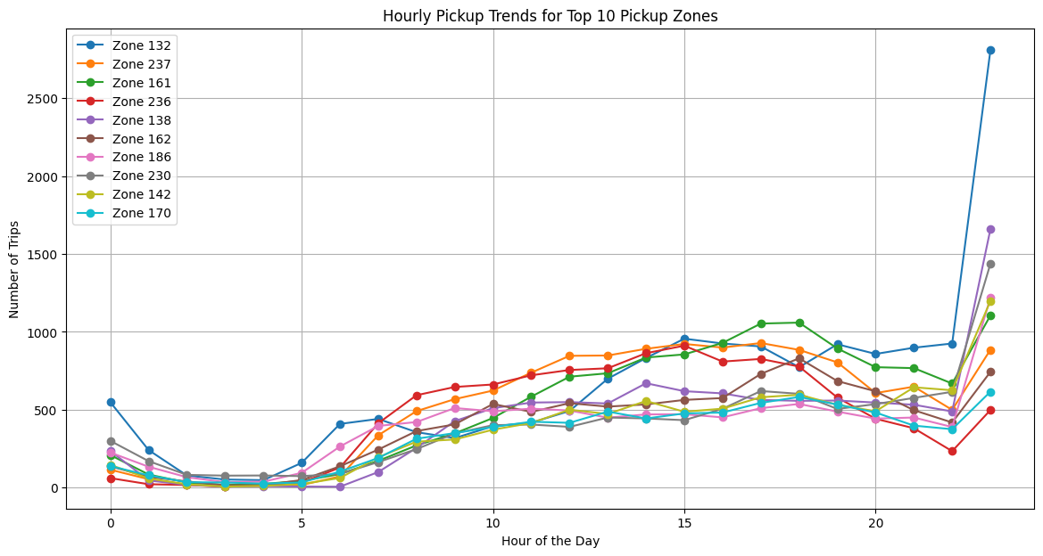
Figure 15: Top pickup zones by hour.
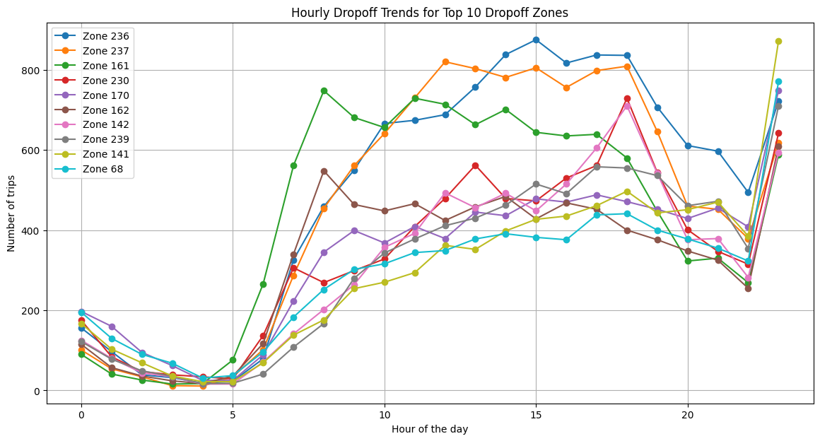
Figure 16: Top dropoff zones by hour.

3.2.6 Find the ratio of pickups and dropoffs in each zone

Zones with a high pickup-to-dropoff ratio indicate areas where taxis are more frequently hired than dropped off. These zones may represent strong demand centers such as business districts, transportation hubs, or nightlife areas. Identifying such zones can help optimize taxi positioning and dispatch strategies. The below chart displays the top 10 zones with the highest pickup-to-dropoff ratios, indicating locations where taxi pickups occur much more frequently than dropoffs. These zones likely represent major commercial areas, business districts, transportation hubs, or high-demand pickup points where passengers commonly request rides.Location ID 70 stands out with an exceptionally high pickup/dropoff ratio of over 10, significantly higher than all other zones. This suggests an extremely strong outbound demand from this area, where many passengers begin trips but relatively few end them. Similarly, Location IDs 132 and 138 also show notably high ratios, indicating concentrated pickup activity.
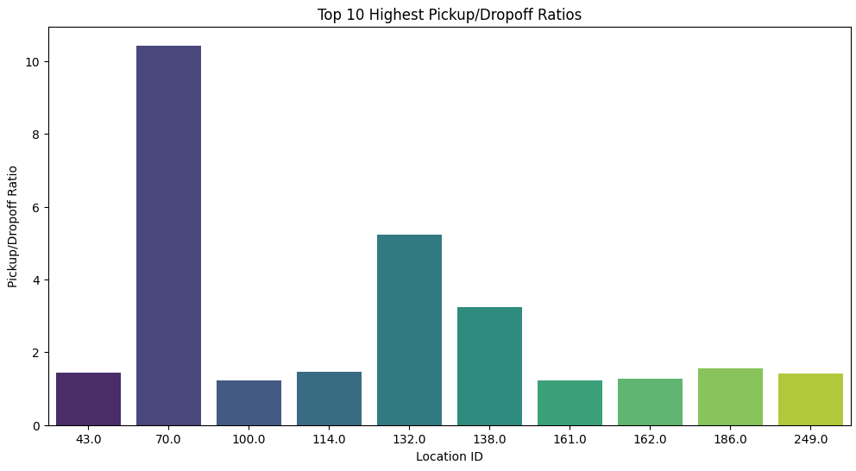
The below chart shows the top 10 zones with the lowest pickup-to-dropoff ratios. These zones have significantly fewer pickups compared to dropoffs, indicating that passengers are more frequently dropped off in these areas than picked up. This suggests that these locations may primarily function as residential zones, airport destinations, or low-demand areas where taxis tend to leave passengers but struggle to find return trips.
Among the displayed zones, Location IDs 101 and 178 have the lowest ratios, indicating the strongest imbalance between pickups and dropoffs. Such patterns may lead to operational inefficiencies, including increased empty return trips. Identifying these low-ratio zones can help taxi operators improve repositioning strategies and optimize cab allocation to improve service efficiency.

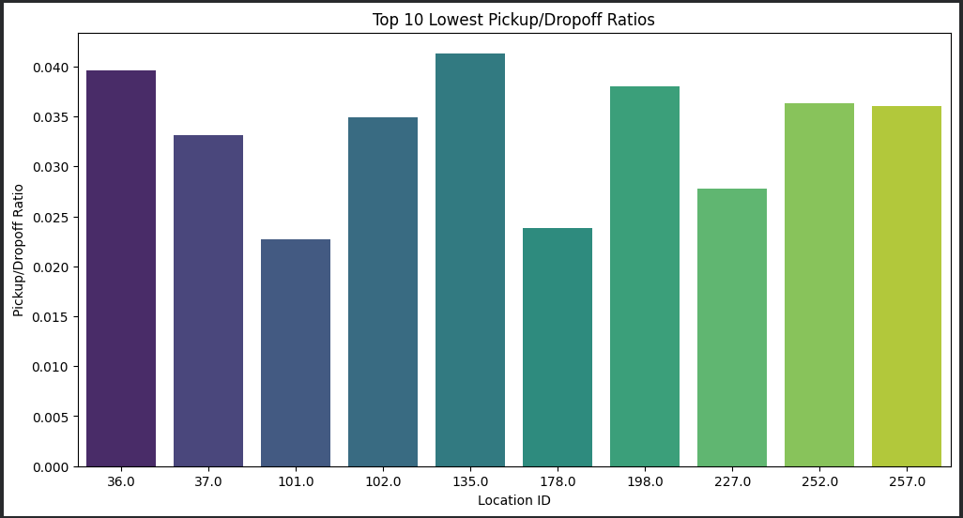

3.2.7 Identify the top zones with high traffic during night hours
Night-time demand from 23:00 to 05:00 was highest in zones such as LocationID 132, 138, 230, 48, and 79 for pickups. High night dropoffs included zones such as 79, 141, 107, 263, and 68.
Zones with higher night hour pickup
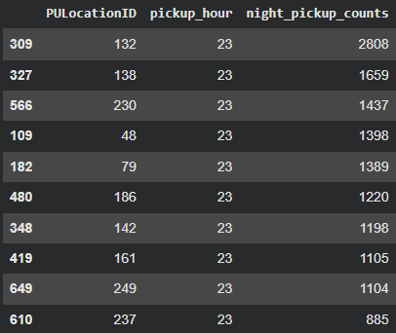
Zones with higher night hour pickup
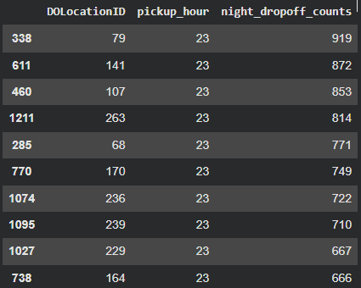

3.2.8 Find the revenue share for nighttime and daytime hours
Daytime generated approximately $6.47 million in total revenue, while night-time generated approximately $1.53 million.
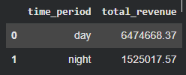

3.2.9 For the different passenger counts, find the average fare per mile per passenger
Fare per mile per passenger was highest for one-passenger trips and declined as passenger count increased. This is expected because the fare is shared across more passengers. The chart illustrates the average fare per mile per passenger for different passenger counts. A clear decreasing trend can be observed as the number of passengers increases. Single-passenger trips have the highest average fare per mile per passenger, at approximately 11.51, since the entire trip cost is paid by one individualFor trips with two to four passengers, the fare per passenger decreases substantially because the travel cost is shared among multiple riders. Although the value for four-passenger trips is slightly higher than that for three-passenger trips, the overall trend still indicates improved cost efficiency with ride sharing. Trips with five and six passengers show the lowest fare per mile per passenger values, around 1.54 and 1.26 respectively. This demonstrates that larger group travel significantly reduces the effective transportation cost for each passenger.
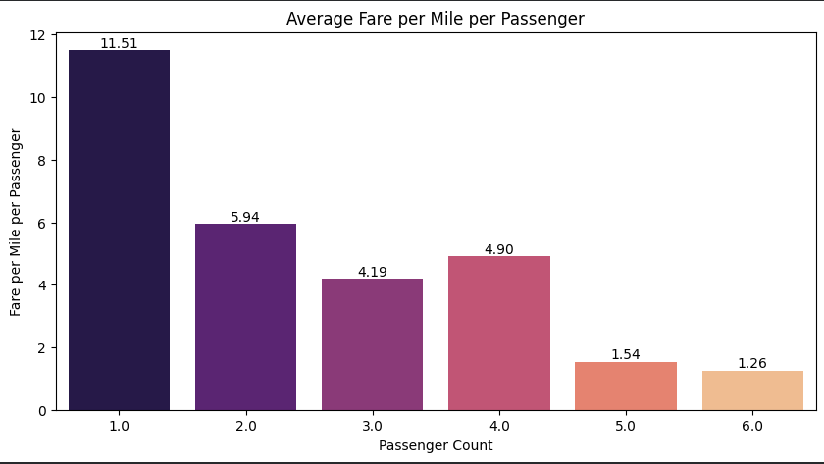

3.2.10 Find the average fare per mile by hours of the day and by days of the week
The heatmap illustrates how the average fare per mile varies across different days of the week and hours of the day. Each cell represents the mean fare per mile for trips occurring during a specific hour on a particular day, with darker colors indicating higher fare-per-mile values. Most weekday daytime hours show relatively stable fare-per-mile values, suggesting consistent pricing patterns during regular commuting periods. However, several strong spikes are visible during late-night and early-morning hours, particularly on Tuesday, Saturday, and Sunday. These periods display significantly higher fare-per-mile values compared to the rest of the week.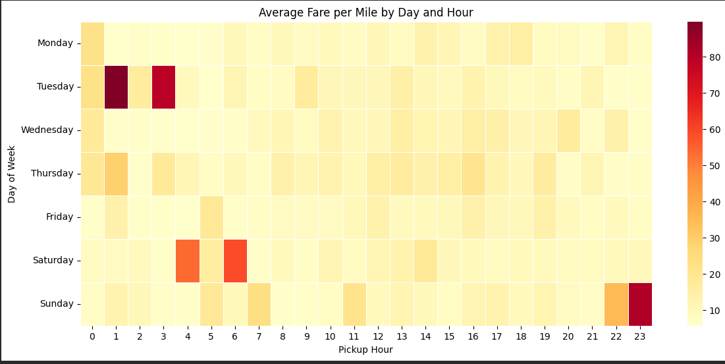

3.2.11 Analyse the average fare per mile for the different vendors
Vendor 2 had a larger number of trips than Vendor 1. The chart compares the average fare per mile for the two taxi vendors across different hours of the day. Vendor 2 consistently shows higher fare-per-mile values than Vendor 1 throughout most hours. Vendor 2 also exhibits greater fluctuations, with sharp spikes during certain late-night and early-morning hours, particularly around 1 AM, 4 AM, and 11 PM. These peaks may be influenced by nighttime surcharges, airport trips, lower taxi availability, or short-distance rides with relatively high fares. In contrast, Vendor 1 maintains a more stable fare pattern with smaller hourly variations. Overall, the analysis suggests that Vendor 2 experiences higher and more variable fare-per-mile rates, while Vendor 1 follows a more consistent pricing trend across the day.
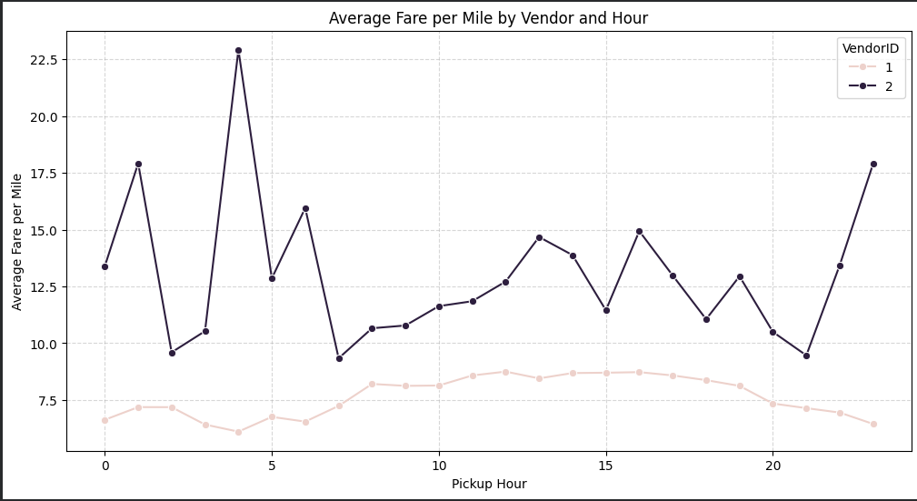

3.2.12 Compare the fare rates of different vendors in a distance-tiered fashion
The chart compares the average fare per mile for different vendors across three distance tiers: trips up to 2 miles, trips between 2 and 5 miles, and trips longer than 5 miles. Both vendors show a clear decrease in fare per mile as trip distance increases. Short-distance trips (up to 2 miles) have the highest fare-per-mile values, especially for Vendor 2, because fixed base charges and minimum fares contribute more heavily to the total trip cost for shorter rides. As trip distance increases, the fare per mile decreases and becomes more stable for both vendors. For medium and long-distance trips, the fare-per-mile values for the two vendors become much closer, indicating more consistent pricing behavior for longer journeys. Overall, the analysis suggests that short trips are relatively more expensive per mile, while longer trips provide better cost efficiency for passengers.

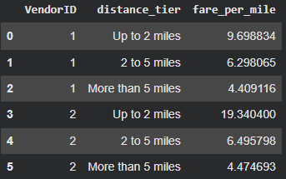
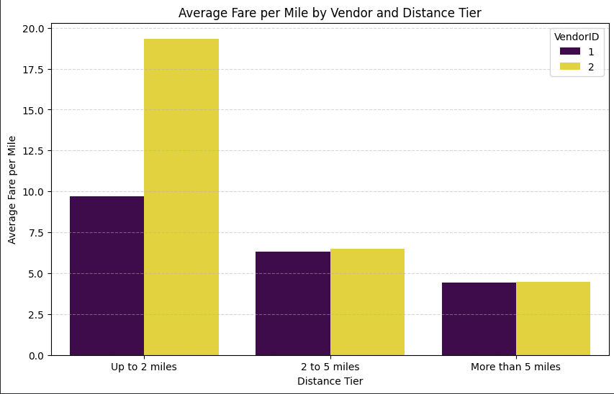

3.2.13 Analyse the tip percentages
The visualization compares average tip percentages across different trip distance tiers, passenger counts, and pickup hours. Each panel represents a distance category, while the lines show tipping behavior for different passenger counts throughout the day. Short-distance trips (up to 2 miles) display the highest variability in tip percentages, with several sharp spikes during late-night and early-morning hours. Medium-distance trips (2 to 5 miles) show relatively more stable tipping patterns, although some fluctuations are still visible during off-peak hours. Long-distance trips (more than 5 miles) exhibit the most consistent tip percentages across the day. Passenger count also influences tipping behavior, but the differences between groups are generally smaller than the effect of trip distance and pickup time. Overall, the analysis suggests that tipping patterns are affected by a combination of trip length, travel timing, and passenger occupancy, with nighttime short-distance trips showing the greatest variation.
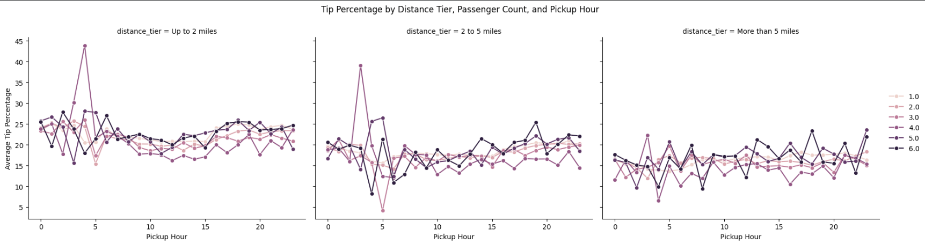

3.2.14 Analyse the trends in passenger count
The heatmap shows the variation in average passenger count across different hours of the day and days of the week. Darker shades represent higher average passenger counts, while lighter shades indicate lower occupancy levels. Passenger counts are generally lower during early morning hours across most weekdays, particularly between 5 AM and 8 AM. Higher passenger counts are observed during evening and nighttime hours, especially on Fridays, Saturdays, and Sundays. Weekend nights show the highest average passenger counts, suggesting increased group travel related to social activities.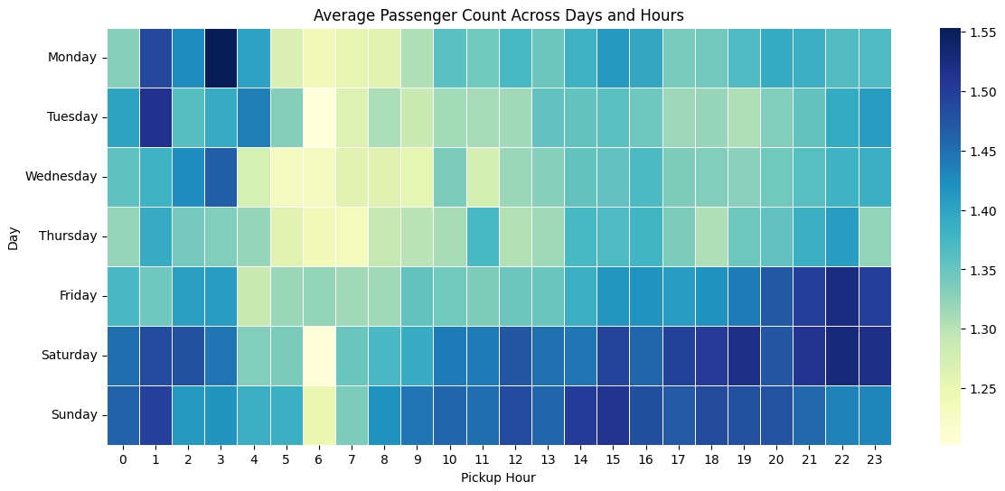

3.2.15 Analyse the variation of passenger counts across zones
Average passenger count varied by zone. Airport and tourist/entertainment zones tended to have slightly higher average passenger counts, while many Manhattan business zones were dominated by one-passenger trips.
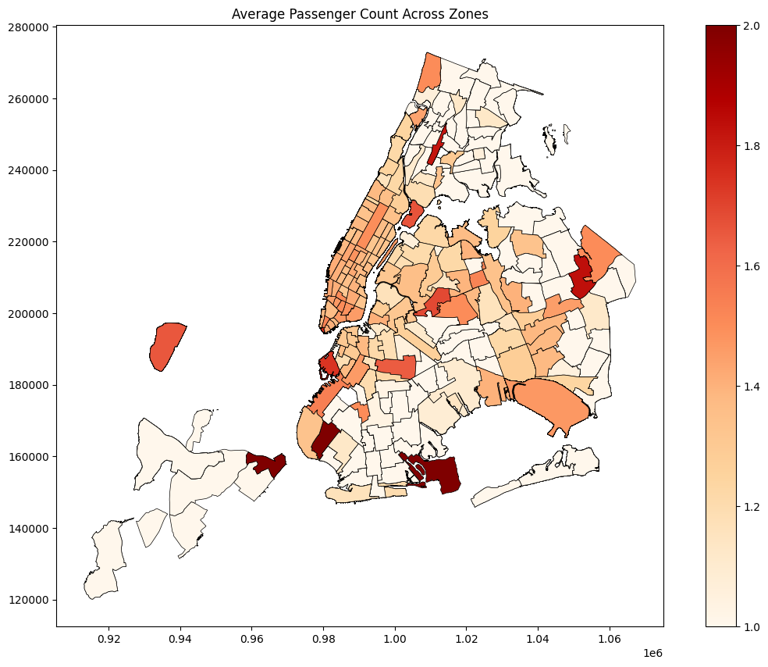
Figure 17: Average passenger count by pickup zone.

3.2.16 Analyse the pickup/dropoff zones or times when extra charges are applied more frequently
The table shows the pickup zones where surcharges are applied most frequently. JFK Airport has the highest surcharge count, followed by Upper East Side South and Midtown Center. On the other hand, the surcharge is higher for dropoff zones such as Upper East Side zones. This indicates that surcharges are more common in airports, busy urban areas, and congested locations with high taxi demand.
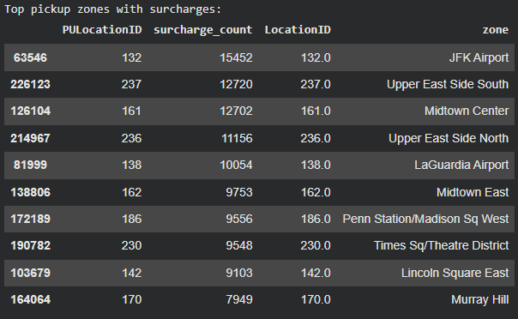
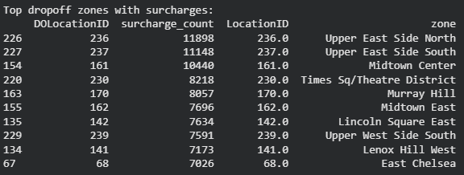
Surcharge frequency is lowest during early morning hours, particularly between 2 AM and 5 AM, and gradually increases throughout the day. The highest surcharge activity occurs during evening and late-night hours, especially around 11 PM, where the number of surcharge-applied trips peaks significantly. This pattern suggests that surcharges are more common during high-demand, congested, and nighttime travel periods.
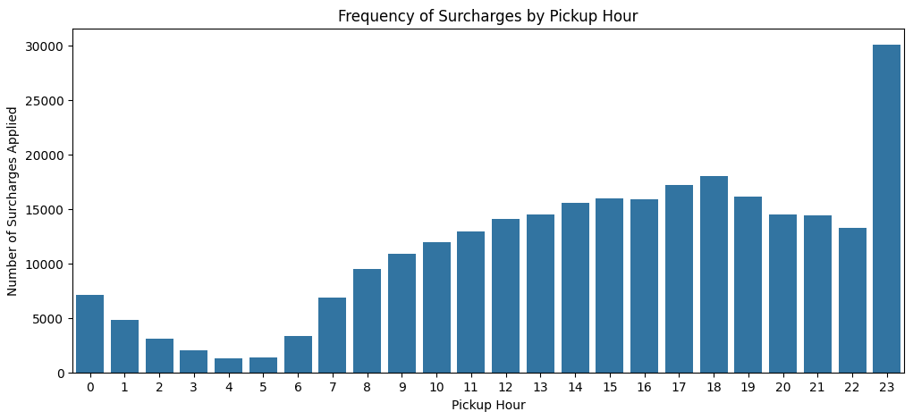

4. Conclusions

4.1 Final Insights and Recommendations

4.1.1 Recommendations to optimize routing and dispatching based on demand patterns and operational inefficiencies
• Allocate more drivers during the busiest hours, especially 15:00-19:00 and 23:00, while reducing idle supply during 03:00-05:00.
• Use route-hour speed analysis to flag bottlenecks and avoid dispatching drivers through slow routes when faster alternatives are available.
• Zones with strong pickup-dropoff imbalances should also be monitored carefully to reduce empty return trips and improve driver utilization.

4.1.2 Suggestions on strategically positioning cabs across different zones
• Prioritise high-demand pickup zones such as LocationIDs 132, 237, 161, 236, 138, 162, 186, 230, 142, and 170.
• During night hours, position more cabs near high night pickup zones such as 132, 138, 230, 48, and 79.
• Use pickup/dropoff ratio analysis to reposition vehicles from zones with high dropoffs but low pickups toward zones with stronger outgoing demand.
• Increase airport and Manhattan availability during high-revenue months and quarters, especially Q2 and Q4.

4.1.3 Propose data-driven adjustments to the pricing strategy
• Maintain competitive fares for 2-5 mile and more-than-5-mile trips because vendor differences are small in these tiers.
• Review short-distance pricing because fare per mile is much higher for short trips, especially for Vendor 2; this may improve revenue but can reduce customer satisfaction if perceived as expensive.
• Use time-sensitive pricing carefully during high-demand late-evening and peak periods, while monitoring tip percentages and payment behaviour.
• Promote card/digital payments because they are associated with clearer tip capture and more complete customer-spend data.
Overall, the analysis shows that NYC taxi operations can be improved by combining time-based demand planning, spatial positioning, route-level speed monitoring, and distance-tiered pricing insights. The strongest operational opportunities are better fleet placement during peak hours, smarter repositioning between pickup-heavy and dropoff-heavy zones, and careful pricing review for short trips and surcharge-heavy locations.

